Explore universities
Search for university (drop-down)
Select country (drop-down)

At the bottom of it show 1 2 3 … 30 next only; it is too long (check this link for corresponding https://globalstudyabroad.com/universities/)

Australian schools
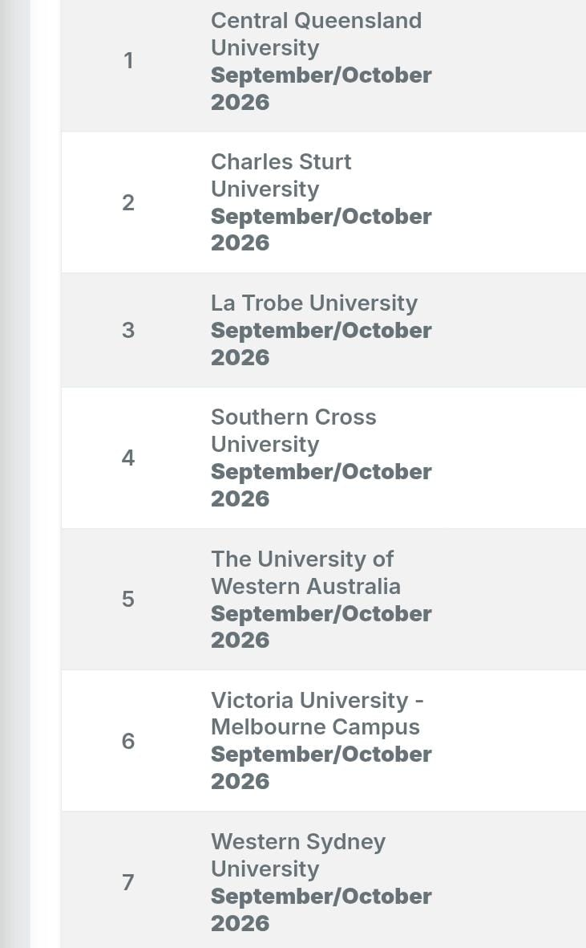

France


Ireland 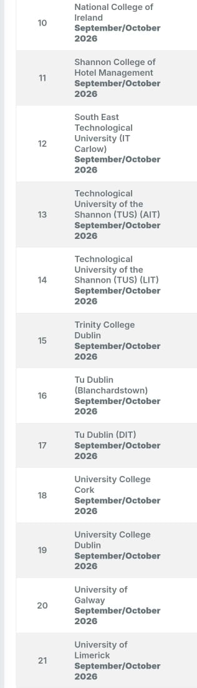

New Zealand schools
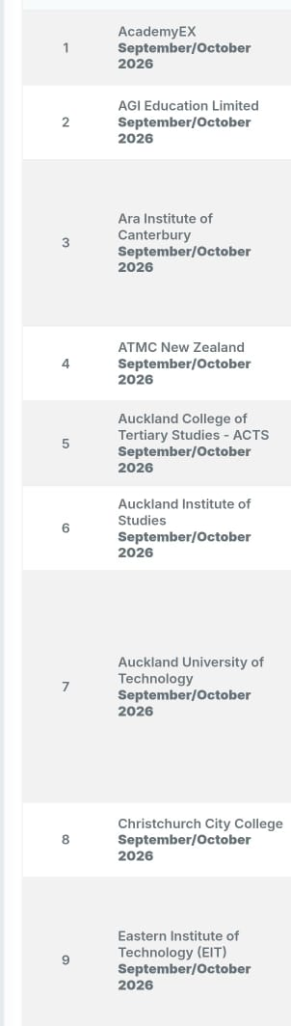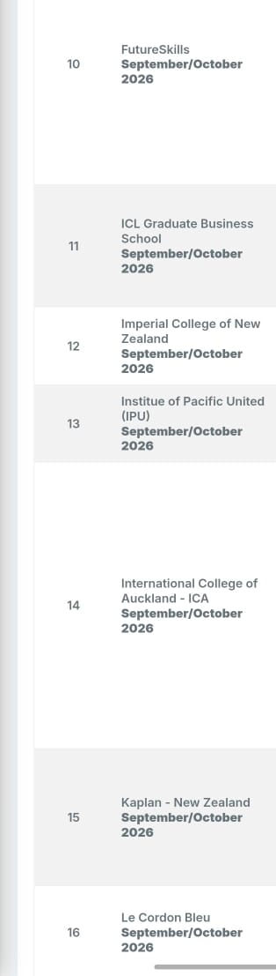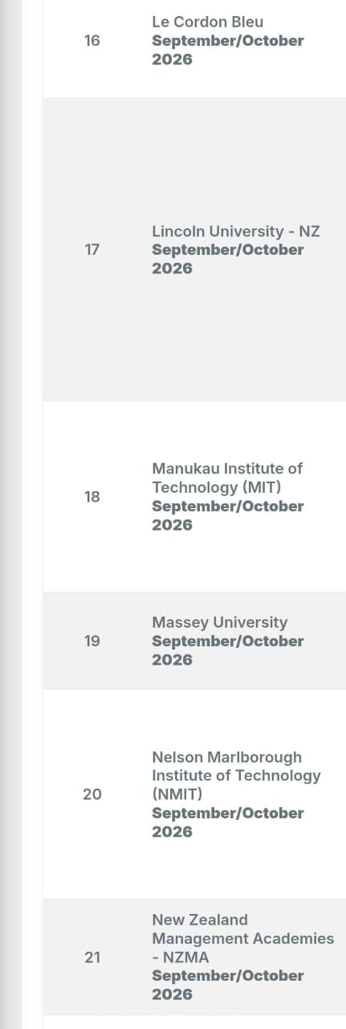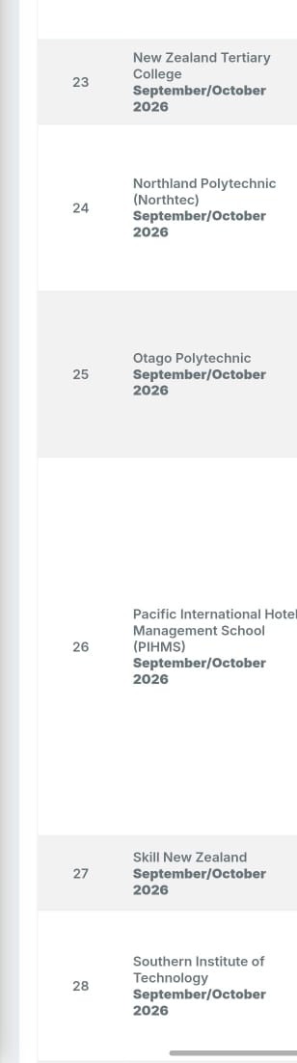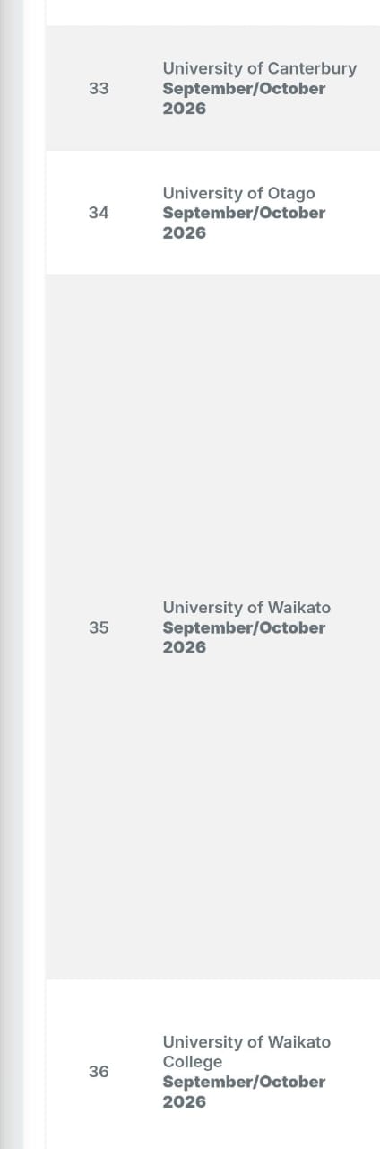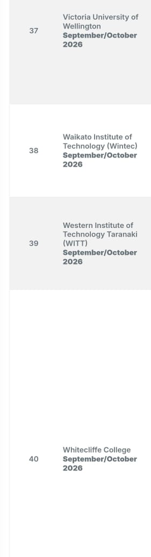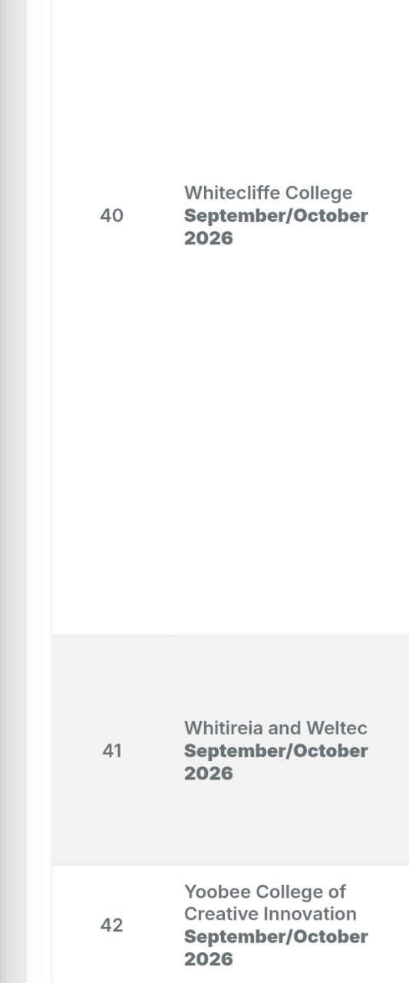
Singapore schools

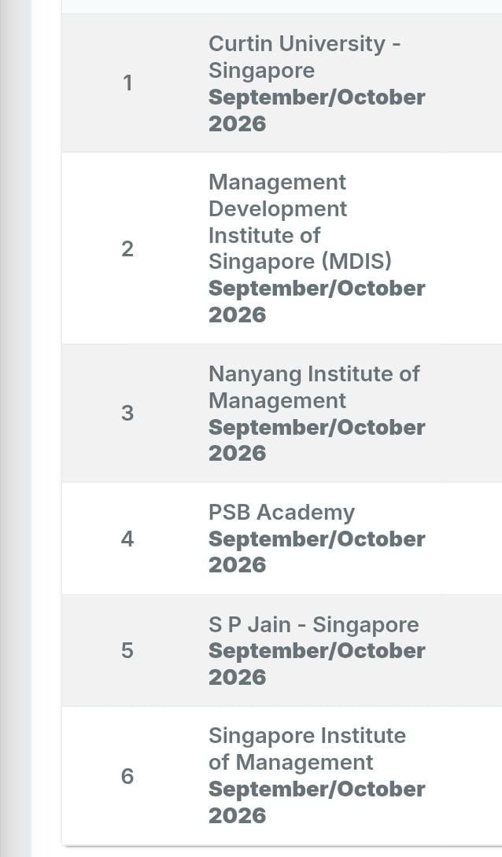

Uk schools
